Filed by Axcelis Technologies, Inc.
Pursuant to Rule 425 under the Securities Act of 1933,
as amended, and deemed filed pursuant to Rule 14a-12
under the Securities Exchange Act of 1934, as amended

Subject Company: Vecco Instruments Inc.
Commission File No.: 0-16244

The following was sent to employees of Axcelis Technologies, Inc. on April 29, 2026:

Here is an update on the Axcelis+Veeco merger activities from President and CEO Dr. Russell Low. - | 



NewCo Update

By Axcelis Communications ● Apr 29, 2026

Smart Brevity® count: 5.5 mins...1447 words

Here is an update on the Axcelis+Veeco merger activities from President and CEO Dr. Russell Low.

Preparing for Merger Success

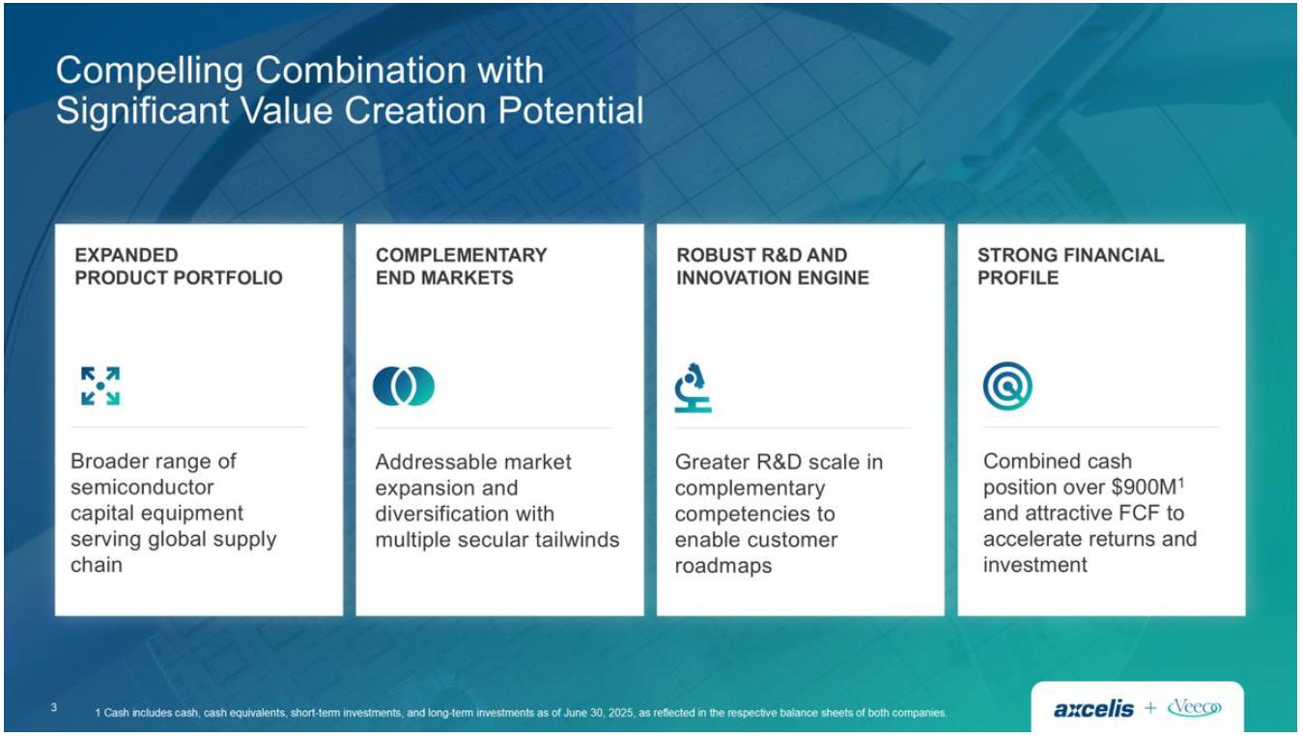

Dear Team,

I’d like to update the organization on activities underway to prepare for the upcoming merger with Veeco. In the spirit of innovation and collaboration, we stand on the brink of an exciting new chapter. The merger with Veeco marks a transformational milestone for both companies, establishing a new leader in semiconductor capital equipment with complementary technologies, a diversified portfolio and an expanded market opportunity.

Here is an update on key activities:

 | • | Regulatory Approvals: The only pending regulatory approval is from the State Administration for Market Regulation of the People’s Republic of China. We expect the merger to close in the second half of 2026.

 | • | Integration Teams continue to make progress across all functional and operational areas. These teams are focused on developing comprehensive plans to help manage key risks and interdependencies, and speed integration activities, so we can hit the ground running on Day One and work to achieve the aspirations of the deal.

 | • | New Corporate Name and Brand Identity development is well underway. We’ve officially wrapped up the Define phase, where our brand identity is starting to take shape. Brand Identity expresses what a brand stands for through distinct, recognizable elements that set it apart from competitors. Elements include color palettes, imagery, tone and voice. Together, these elements tell a cohesive brand story. A clear identity increases brand awareness, improves marketing effectiveness, and helps attract and retain the right audience.

We will keep you updated as information is available.

Sincerely,

Dr. Russell Low
President & CEO

Additional Information About the Potential Transaction and Where to Find It

In connection with the proposed transaction between Axcelis and Veeco pursuant to the Merger Agreement, on December 8, 2025, Axcelis filed with the Securities and Exchange Commission (the “SEC”) a registration statement on Form S-4, as amended on December 29, 2025 (the “Registration Statement”). The Registration Statement on Form S-4 was declared effective by the SEC on December 31, 2025. Each of Axcelis and Veeco filed a definitive joint proxy statement/prospectus (the “Joint Proxy Statement/Prospectus”) with the SEC on December 31, 2025 and commenced mailing to their respective stockholders on or about December 31, 2025. Each of Axcelis and Veeco may also file with or furnish to the SEC other relevant documents regarding the proposed Merger. This communication is not a substitute for the Joint Proxy Statement/Prospectus or any other document that Axcelis or Veeco has filed or may file with or furnish to the SEC. INVESTORS AND SECURITY HOLDERS ARE URGED TO READ THE JOINT PROXY STATEMENT/PROSPECTUS AND ANY OTHER RELEVANT DOCUMENTS THAT ARE OR WILL BE FILED WITH OR FURNISHED TO THE SEC, AS WELL AS ANY AMENDMENTS OR SUPPLEMENTS TO THESE DOCUMENTS, CAREFULLY AND IN THEIR ENTIRETY BECAUSE THEY CONTAIN OR WILL CONTAIN IMPORTANT INFORMATION ABOUT THE PROPOSED MERGER AND RELATED MATTERS. Investors and security holders will be able to obtain free copies of the Joint Proxy Statement/Prospectus and other documents containing important information about Axcelis, Veeco and the proposed transaction, once such documents are filed with or furnished to the SEC through the website maintained by the SEC at www.sec.gov. Copies of the documents filed with or furnished to the SEC by Axcelis will be available free of charge on Axcelis’ website at investor.axcelis.com or by contacting Axcelis’ Investor Relations department by email at Investor-Relations@axcelis.com. Copies of the documents filed with or furnished to the SEC by Veeco will be available free of charge on Veeco’s website at ir.veeco.com or by contacting Veeco’s Investor Relations department by email at Investorrelations@veeco.com.

No Offer or Solicitation

This communication is not intended to and shall not constitute an offer to purchase or the solicitation of an offer to buy or sell any securities, or a solicitation of any vote or approval, nor shall there be any sale of securities in any jurisdiction in which such offer, solicitation or sale would be unlawful prior to registration or qualification under the securities laws of any such jurisdiction. No offer of securities shall be made, except by means of a prospectus meeting the requirements of Section 10 of the Securities Act of 1933, as amended.

Forward-Looking Statements

Certain statements included in this communication, and any related oral statements, that are not historical facts are forward-looking statements for purposes of the safe harbor provisions under the United States Private Securities Litigation Reform Act of 1995. Statements in this communication other than historical facts, such as statements pertaining to: (i) future industry demand for semiconductors and wafer fabrication equipment; (ii) future development of regulatory landscape; (iii) Axcelis’ or Veeco’s market position for the future; (iv) forecasts of financial measures for future periods; (v) long-term financial targets and underlying assumptions; (vi) the future investment plan for research and development, technology and infrastructure; (vii) future shareholder returns; and (viii) potential synergies or other benefits of a potential transaction between Axcelis and Veeco, are forward-looking statements.

Any statements that involve discussions with respect to predictions, expectations, beliefs, plans, projections, objectives, assumptions, future events, or performance (often but not always using phrases such as “expects” or “does not expect,” “is expected,” “anticipates” or “does not anticipate,” “plans,” “budget,” “scheduled,” “forecasts,” “estimates,” “believes” or “intends” or variations of such words and phrases or stating that certain actions, events or results “may” or “could,” “would,” “might” or “will” be taken to occur or be achieved) are not statements of historical fact and may be forward-looking information and are intended to identify forward-looking information.

These forward-looking statements are based on current information and assumptions and involve a number of risks and uncertainties, including relating to obtaining applicable regulatory and stockholder approvals, satisfying other closing conditions to the proposed transaction, the expected tax treatment of the proposed transaction, the expected timing of the proposed transaction and the integration of the businesses and the expected benefits, cost savings, accretion, synergies and growth to result therefrom. These risks include, among other things: failure to obtain applicable regulatory or stockholder approvals in a timely manner or otherwise; failure to satisfy other closing conditions to the proposed transaction or to complete the proposed transaction on anticipated terms and timing; negative effects of the announcement of the proposed transaction; risks that the businesses will not be integrated successfully or that the combined company will not realize expected benefits, cost savings, accretion, synergies and/or growth, or that such benefits may take longer to realize or may be more costly to achieve than expected; the risk that disruptions from the proposed transaction will harm business plans and operations; risks relating to unanticipated costs of integration; significant transaction and/or integration costs, or difficulties in connection with the proposed transaction and/or unknown or inestimable liabilities; restrictions during the pendency of the proposed transaction that may impact the ability to pursue certain business opportunities or strategic transactions; potential litigation associated with the proposed transaction; the potential impact of the announcement or consummation of the proposed transaction on Axcelis’, Veeco’s or the combined company’s relationships with suppliers, customers, employees and regulators; and demand for the combined company’s products. Actual results may differ materially from those projected in such statements due to various factors, including but not limited to: economic, political and social conditions in the countries in which Axcelis and Veeco, their respective customers and suppliers operate; disruption to Axcelis’ and Veeco’s respective manufacturing facilities or other operations, or the operations of Axcelis’ and Veeco’s respective customers and suppliers, due to natural catastrophic events, health epidemics or terrorism; ongoing changes in the technology industry, and the semiconductor industry in particular, including future growth rates, pricing trends in end-markets, or changes in customer capital spending patterns; Axcelis’, Veeco’s and the combined company’s ability to timely develop new technologies and products that successfully anticipate or address changes in the semiconductor industry; Axcelis’, Veeco’s and the combined company’s ability to maintain their respective technology advantage and protect their respective proprietary rights; Axcelis’, Veeco’s and the combined company’s ability to compete with new products introduced by their respective competitors; Axcelis’, Veeco’s and the combined company’s ability or the ability of their respective customers to obtain U.S. export control licenses for the sale of certain products or provision of certain services to customers in China.

For other factors that may cause actual results to differ materially from those projected and anticipated in forward-looking statements in this communication, please refer to Axcelis’ most recent Annual Report on Form 10-K and Veeco’s most recent Annual Report on Form 10-K, and other subsequent filings with the SEC made by Axcelis and/or Veeco. Unless required by law, we assume no obligation to, and do not currently intend to, update these forward-looking statements.



